**Tigerspike Challenge – Wireframe**

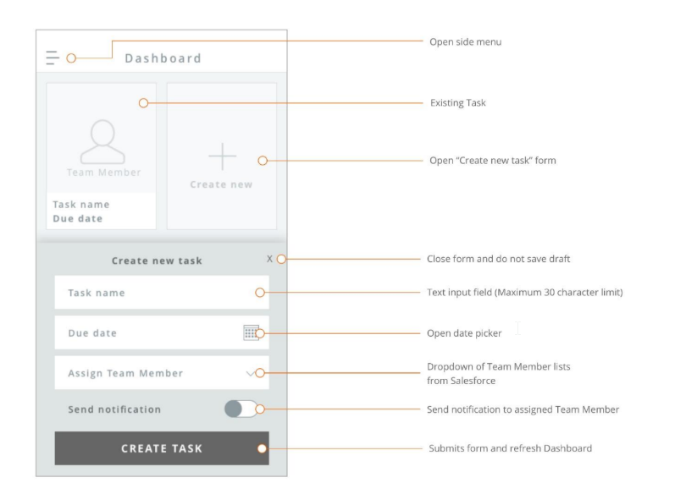

**<User Story**>

As a user, I should be able to create a task for a sales force member and view the existing task in the dashboard with the task name and due date for the assigned team member and send email notification to the assigned team member indicating about the task

**< Precondition>**

* User has already login to the application

**<Acceptance criteria>**

**System must be able to:**

1. Display the side menu list
2. Allow user to click the + icon to create a new task form
   * The new task form should be displayed at the bottom the page
3. Allow user to enter the Task name
   1. Allows the user to enter the task name maximum of 30 characters limit
4. Allow user to select the date picker to select the due date
   * The due date should not be allowed to select in the past
5. Allow user to Assign Team Members from the Dropdown list from Sales force
6. Allow user to turn ON/OFF the toggle key to send the notification to the assigned sales force team member
7. After all fields are entered, allow user to Click “CREATE TASK “to submit the form.
8. Allow user to view the submitted team member task in the Dashboard with the task name and due date
9. Allow user to close the “Create new task” form and no draft of the form is saved

**<Test cases >**

1. Verify the user can successfully login to the application
2. After user login, Verify the Dashboard is displayed to start to create task for a sales force member
3. Verify by selecting the + icon, the Open the new task form should be displayed at the bottom of the page
4. User enters the task name and verify that the task name does not accept more than 30 characters
5. Verify that the user can select the date picker to choose the due date for the task
6. Verify if the calendar component loads properly after click on any date box.
7. Verify if the calendar control is by default shows the date, month, a year as per the system date.
8. Verify that the date picker is not allowed to select a date in the past
9. Verify the date selected displays in the format dd/mm/yy or mm/dd/yy
10. Verify the User is able the select the sales force team member from the drop-down list
11. Verify that the User types the team member name in the drop-down list should display the name of the selected sales force person.
12. Verify the Drop down should be scrolled down by clicking down arrow key in the application
13. Verify the User can turn ON the notification by setting the toggle to ON
14. Verify the User can turn OFF the notification by setting the toggle to OFF
15. Verify user enters all the fields and Taps ‘Create Task’ button, The Task is created successfully in the dashboard
16. Verify that the Task created is seen in the dashboard with the task member name, task name and due date
17. Verify after the task is created, the assigned task sales force task member receives the notification by email or SMS if the Send Notification toggle was set to ON
18. Verify after the task is created, the assigned task sales force task member does not receive the notification if the Send Notification toggle was set to OFF
19. Verify that the form is not saved as draft when the user enters all the fields to create the task and users chooses to Close the form by selecting the ‘X’
20. Check the “Create Task” button is enabled only if all the 3 fields (Task name, Due Date and Assign team member) is entered
21. Verify by default the ‘Send notification’ toggle is set to ON
22. Verify that the user selects the Side menu by selecting the side menu icon in the upper left side of the dashboard
23. Verify the task name contains only characters and no numerals or special characters are allowed

**QA Approach:** Testing is not related to the execution of test cases and to find defects. Testing includes many activities in each phase of the development life cycle such as requirement verification, verify design, create test plan, etc. So, software testing activity should be started as soon as possible in the development life cycle. Test Analyst will be involved with the BA, Solution Architect, Developers and UI/UX designer during the different stages of SDLC